SimAI-NS3 Simulation Pipeline
- Create a conda environment with any python version (For GPU1 use torchb conda environment)

Troubleshooting:

Action | Command
Uninstall Ninja packages before compilation | apt remove ninja-build && pip uninstall ninja
g++/gcc should be of the same version

- Follow the Quick start instructions to compile the SimAI-NS3

- Before compiling SimAI-NS3, modify the path for SIM_LOG_DIR=/home/gpu1/sumit/SimAI/astra-sim-logs in SimAI/astra-sim-alibabacloud/build.sh

  - Compile SimAI-NS3: sudo ./scripts/build.sh -c ns3
(Note: Ensure g++/gcc are of the same version)

- In SIM_LOG_DIR, add empty output / input files as demonstrated in SimAI/astra-sim-alibabacloud/inputs/config/SimAI.conf (namely FLOW_FILE, TRACE_FILE, TRACE_OUTPUT_FILE, FCT_OUTPUT_FILE, PFC_OUTPUT_FILE) . Also modify the paths in the .conf file w.r.t. the SIM_LOG_DIR path.

- Give read-write permissions to the files in SIM_LOG_DIR : chmod 777 *

- Create the network topology file:
  - python3 ./astra-sim-alibabacloud/inputs/topo/gen_Topo_Template.py -topo Spectrum-X -g 128 -gt A100 -bw 100Gbps -nvbw 2400Gbps

- Run simulation:
  - gdb -args ./bin/SimAI_simulator -t 16 -w ./example/microAllReduce.txt -n ./Spectrum-X_128g_8gps_100Gbps_A100 -c astra-sim-alibabacloud/inputs/config/SimAI.conf
  - (gdb) run

- Output:
  - Check ${SIM_LOG_DIR}/simulations/ path for the mix.tr file

- AstraSim output analysis

clone the HPCC repository
```
$ git clone git@github.com:alibaba-edu/High-Precision-Congestion-Control.git
```

Compile the trace reader target:
```
$ cd High-Precision-Congestion-Control/analysis
$ make trace_reader
```

Run the deserailizer to get packet level information about the simulation:
```
$ ./trace_reader ../../mix.tr > out.txt
```

Then we can analyze the `out.txt` file.

Workload Extrapolator in SimAI:

- Create / use your conda environment with any python version
- Install dependencies using Dockerfile:
  - docker build -t aicb:v0.0.1 .
    - In case of errors in ./aicb/Dockerfile:
      - upgrade pip using ‘ python -m pip install --upgrade pip’
      - comment out ‘pip3 install einops’ and install separately using ‘pip install einops’
  - docker run --gpus all --net host --shm-size 16g -it --rm aicb:v0.0.1
- Generate Custom traces using (in SimAI/aicb/ directory):
GPT7B (Realistic) :
python -m workload_generator.AIOB_simAI_workload_generator --model_name GPT-7B --frame=Megatron --world_size=128 --tensor_model_parallel_size=2 --pipeline_model_parallel=1 --global_batch=976 --micro_batch=1 --num_layers=32 --seq_length=2048 --hidden_size=4096 --ffn_hidden_size=16384 --vocab_size=50257 --epoch_num=10 --use-distributed-optimizer --num_attention_heads=32 --max_position_embeddings=2048 --aiob_enable --use_flash_attn --swiglu

- Model.txt stored at SimAI/results/workload/ directory.

- Generate network topology appropriate for the extrapolated model trace (https://github.com/aliyun/SimAI/blob/master/docs/Tutorial.md#topo-templates ).
  - Example: python3 ./astra-sim-alibabacloud/inputs/topo/gen_Topo_Template.py -topo Spectrum-X -g 16 -gt A100 -bw 100Gbps -nvbw 2400Gbps
- Run simulation:
  - gdb -args ./bin/SimAI_simulator -t 16 -w .<model.txt path> -n <network topology file path> -c astra-sim-alibabacloud/inputs/config/SimAI.conf
  - (gdb) run
- Output:
  - Check ${SIM_LOG_DIR}/simulations/ path for the mix.tr file

Error | Solution
ImportError: /home/gpu1/anaconda3/envs/torchb/bin/../lib/libstdc++.so.6: version `GLIBCXX_3.4.30' not found (required by /home/gpu1/arjun/pytorch_src_build/pytorch/torch/lib/libtorch_python.so) | ln -sf /usr/lib/x86_64-linux-gnu/libstdc++.so.6 /home/gpu1/anaconda3/envs/torchb/bin/../lib/libstdc++.so.6  https://askubuntu.com/questions/1418016/glibcxx-3-4-30-not-found-in-conda-environment
–global-option : not installed
–build-option: error

Workload Generation by running on physical GPUs:

- Deepspeed
torchrun --nnodes 1 --nproc_per_node 2 --master_addr 192.168.3.214 --master_port 29400 ./aicb.py --frame=DeepSpeed --stage=3 --world_size=4 --global_batch=16 --epoch_num=1 --num_layers=40 --hidden_size=5120 --ffn_hidden_size=5120 --num_attention_heads=40

- Megatron

torchrun --nnodes 1 --nproc_per_node 2 --master_addr 192.168.3.214 --master_port 29400 ./aicb.py --frame=Megatron --world_size=2 --tensor_model_parallel_size=4 --micro_batch=1 --global_batch=4 --epoch_num=1 --swiglu --num_layers=40 --hidden_size=5120 --ffn_hidden_size=5120 --num_attention_heads=40 $sp_enable --seq_len=2048 --vocab_size=100

Metrics measured:
comm_type,comm_group,comm_group_size,msg_size,stage,dst,src,additional,_elapsed_time,algbw,busbw,count

Detailed info for AICB iteration time
----------------------------------------------------------------------------------------------------------------------------
Init time Max iteration time Min iteration time Avg iteration time P90 iteration time Iteration time Std
----------------------------------------------------------------------------------------------------------------------------
4740.00 4740.00 4740.00 4740.00 4740.00 0.00

b) –aiob-enable: /usr/local/lib/python3.10/dist-packages/workload_generator

Mixture of Parallelism Techniques:
Data + Model

Papers with detailed analysis of traffic patterns for different parallelism techniques? .

- Increase the no. of GPUs in powers of 2.

Q. What questions do we want to answer?
- Fix System + Network Configuration : Job Completion, RDMA related stats (qpairs/sec) , packet losses + congestion control algorithms

Monitor GPU every 1 sec : nvidia-smi dmon -s u -d 1

AstraSim: Workload.cc file (iterator over nodes)

Experiments

Workload for GPT-175B (64GPUs):

python -m workload_generator.AIOB_simAI_workload_generator \
--model_name GPT-175B --frame=Megatron \
--world_size=64 --tensor_model_parallel_size=2 --pipeline_model_parallel=1 --global_batch=16 \
--micro_batch=1 --num_layers=96 --seq_length=2048 \
--hidden_size=12288 --ffn_hidden_size=49152 --vocab_size=50257 --max_position_embeddings=2048 --epoch_num=1 \
--use-distributed-optimizer --num_attention_heads=96 \
--aiob_enable --use_flash_attn --swiglu

Corresponding Network Topology file:

python3 ./astra-sim-alibabacloud/inputs/topo/gen_Topo_Template.py -topo DCN+ -g 64 -gps 8 -asn 1 -psn 1 -app 1 -gt A100 -bw 100Gbps -nvbw 2400Gbps

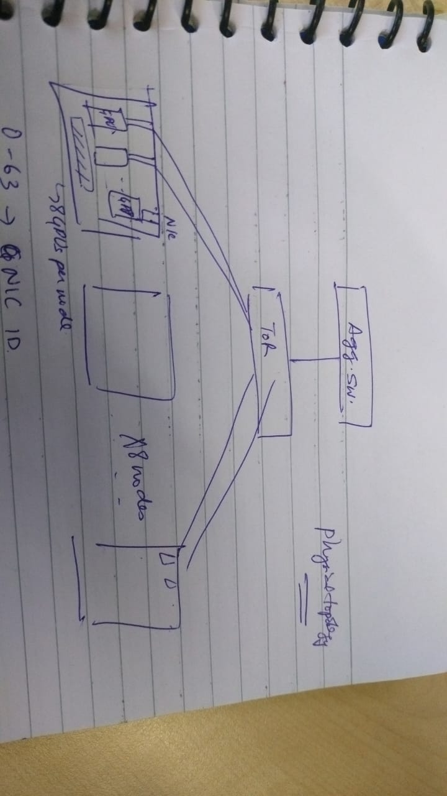
NS3 Simulation:

AS_SEND_LAT=3 ./bin/SimAI_simulator -t 64 -w ./aicb/results/workload/None-GPT-175B-world_size64-tp4-pp1-ep1-gbs16-mbs1-seq20
48-MOE-False-GEMM-False-flash_attn-True.txt -n DCN+SingleToR_64g_8gps_100Gbps_A100 -c astra-sim-alibabacloud/inputs/config/SimAI.conf

(base) gpu1@gpu1:~/sumit/SimAI$ python3 ./astra-sim-alibabacloud/inputs/topo/gen_Topo_Template.py -topo Spectrum-X --ro -g 1024 -gps 8 -gt H100 -bw 100Gbps -nvbw 2400Gbps
/home/gpu1/sumit/SimAI/./astra-sim-alibabacloud/inputs/topo/gen_Topo_Template.py:18: UserWarning: Error relations between total GPU Nums and total aws_switch_num.
The correct asw_switch_num is set to 16
warnings.warn("Error relations between total GPU Nums and total aws_switch_num.\n \
asw_switch_num: 16
psw_switch_num: 64
Creating Topology of totally 2 segment(s), totally 1 pod(s).
Spectrum-X_1024g_8gps_100Gbps_H100

sh ./scripts/megatron_workload_with_aiob.sh -m 175 \
--world_size 1024 --tensor_model_parallel_size 8 --pipeline_model_parallel 1 \
--frame Megatron --global_batch 1024 \
--micro_batch 1 --seq_length 2048 --swiglu \
--use_flash_attn --aiob_enable

NS3 Simulation:

AS_SEND_LAT=3 AS_NVLS_ENABLE=1 ./bin/SimAI_simulator -t 64 -w ./aicb/results/workload/None-gpt_175B-world_size1024-tp8-pp1-ep1-gbs1024-mbs1-seq2048-MOE-False-GEMM-False-flash_attn-True.txt -n ./Spectr
s_H100 -c astra-sim-alibabacloud/inputs/config/SimAI.conf

Analysis

- Convert mix.tr file into .txt

./trace_reader ../llama_hpn7_mix.tr > ./mix-analysis/gpt22-128gpus-mix.txt

- Convert mix.txt to a readable IP address

python3 binary-ip.py gpt22-128gpus-mix.txt gpt22-128gpu-ip.txt

- Split the traces.

python3 split-trace.py gpt22-128gpu-ip.txt ./trace_output/gpu22-128gpu.txt

- Analyze the trace.

FAQs
Q. What is NVLS in NS3 simulation for SimAI?
NVLS refers to NVLink Sharp + IB Sharp, an all-reduce offload to NVSwitch for intra-node communication between GPUs and IBSharp being an inter-node offload solution. Ref: the nvlink-network switch: nvidia's switch chip for high communication-bandwidth superpods
It is available on systems that have H100 and NVLink4 switches (Ref: https://github.com/NVIDIA/nccl/issues/807 )

Q. NVLSTree : NVSharp + Tree (Ref: https://docs.nvidia.com/deeplearning/nccl/pdf/NCCL-Release-Notes.pdf )

Q. PXN : PCI x NVLink
Rail-only Ring Topology for A100/H100 GPUs.
https://developer.nvidia.com/blog/doubling-all2all-performance-with-nvidia-collective-communication-library-2-12/

QPair logs in SimAI NS3:
Original astrasim ns3 rdma.cc: /home/gpu1/sumit/astra-sim/extern/network_backend/ns-3/src/point-to-point/model/rdma-hw.cc

Modified (for qpairs): branch ‘master’
/home/gpu1/astra-sim/extern/network_backend/ns-3/src/point-to-point/model/rdma-hw.cc

In SimAI:

./ns-3-alibabacloud/simulation/src/point-to-point/model/rdma-hw.cc

Diff commands:

> #include "ns3/log.h"
14a16
> #include <arpa/inet.h>
15a18,25
> NS_LOG_COMPONENT_DEFINE("RdmaHW");
>
>
> void DecimalToIpv4(uint32_t decimal, char *ipv4Str) {
> struct in_addr ipAddr;
> ipAddr.s_addr = htonl(decimal); // Convert to network byte order
> inet_ntop(AF_INET, &ipAddr, ipv4Str, INET_ADDRSTRLEN); // Convert to string format
> }
232a243,246
> NS_LOG_INFO("Queue Pair created: src=" << src << ", dest=" << dest
> << ", tag=" << tag << ", size=" << size << ", sip=" << sip << ", dip=" << dip
> << ", sport=" << sport << ", dport=" << dport);
>
272a287
> NS_LOG_INFO("Queue Pair deleted: dip=" << qp->dip << ", sport=" << qp->sport);
490a506,512
> char sipp[INET_ADDRSTRLEN];
> char dipp[INET_ADDRSTRLEN];
> DecimalToIpv4(ch.sip, sipp);
> DecimalToIpv4(ch.dip, dipp);
> std::string sip_s(sipp), dip_s(dipp);
> NS_LOG_INFO("Received packet: protocol=" << ch.l3Prot
> << ", sip=" << sip_s << ", dip=" << dip_s);
549a572,573
> NS_LOG_INFO("Queue Pair completed: sip=" << qp->sip << ", dip=" << qp->dip
> << ", sport=" << qp->sport << ", dport=" << qp->dport);
636a661,662
> NS_LOG_INFO("Packet sent from Queue Pair: sip=" << qp->sip << ", dip=" << qp->dip
> << ", size=" << pkt->GetSize() << ", interframeGap=" << interframeGap);

Simulation command:

./bin/SimAI_simulator -t 16 -w ../../himanshu/workload-files/None-GPT_22B-world_size128-tp4-pp1-ep1-gbs256-mbs1-seq2048-MOE-False-GEMM-False-flash_attn-True.txt -n ./Spectrum-X_128g_8gps_100Gbps_A100 -c astra-sim-alibabacloud/inputs/config/SimAI.conf

Realistic Traces
Nemo (NVIDIA): https://github.com/NVIDIA/NeMo/tree/main

- For LLAMA 405B (Realistic)
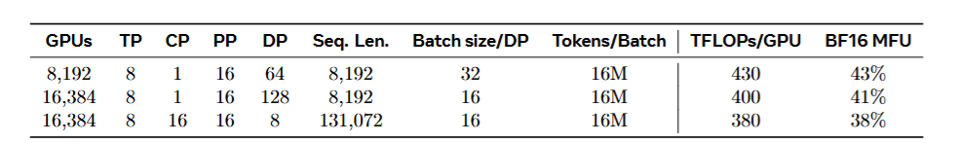

Batch size: 16M/8192 = 1954
Micro batch size: 32

python -m workload_generator.AIOB_simAI_workload_generator --model_name LLAMA-405B --frame=Megatron --world_size=8192 --tensor_model_parallel_size=8 --pipeline_model_parallel=16 --global_batch=1954 --micro_batch=32 --num_layers=126 --seq_length=8192 --hidden_size=16384 --ffn_hidden_size=53248 --vocab_size=128256 --epoch_num=1 --use-distributed-optimizer --num_attention_heads=128 --max_position_embeddings=8192 --aiob_enable --use_flash_attn --swiglu

- For LLAMA (70B) :
python -m workload_generator.AIOB_simAI_workload_generator --model_name LLAMA2-70B --frame=Megatron --world_size=2048 --global_batch=488 --micro_batch=1 --epoch_num=10 --num_layers=80 --hidden_size=8192 --num_attention_heads=64 --seq_length=4096 --vocab_size=128256 --max_position_embeddings=4096 --ffn_hidden_size=28672 --tensor_model_parallel_size=8 --pipeline_model_parallel=8 --use_flash_attn --swiglu --aiob_enable

- For GPT 175B

python -m workload_generator.AIOB_simAI_workload_generator --model_name GPT-175B --frame=Megatron --world_size=1024 --tensor_model_parallel_size=8 --pipeline_model_parallel=8 --global_batch=2048 --micro_batch=16 --num_layers=96 --seq_length=2048 --hidden_size=12288 --ffn_hidden_size=49152 --vocab_size=50257 --epoch_num=1 --use-distributed-optimizer --num_attention_heads=96 --max_position_embeddings=2048 --aiob_enable --use_flash_attn --swiglu

Topology File (Rail only Topology):
python3 ./astra-sim-alibabacloud/inputs/topo/gen_Topo_Template.py -topo Spectrum-X -g 1024 -asn 8 -npa 128 -gps 8 -gt A100 -bw 100Gbps -nvbw 2400Gbps -psn 0

Simulation Command:
What should be the pkt sending latency?

for A100:

./bin/SimAI_simulator -t 64 -w ~/sumit/SimAI/aicb/realistic_workloads/A100/None-GPT-175B-world_size1024-tp8-pp8-ep1-gbs2048-mbs2-seq2048-MOE-False-GEMM-False-flash_attn-True-A100.txt -n ~/sumit/SimAI/aicb/realistic_workloads/A100/Spectrum-X_1024g_8gps_100Gbps_A100 -c astra-sim-alibabacloud/inputs/config/SimAI.conf

for H100:
./bin/SimAI_simulator -t 64 -w ~/sumit/SimAI/aicb/realistic_workloads/H100/None-GPT-175B-world_size1024-tp8-pp8-ep1-gbs2048-mbs2-seq2048-MOE-False-GEMM-False-flash_attn-True-H100.txt -n ~/sumit/SimAI/aicb/realistic_workloads/H100/Spectrum-X_1024g_8gps_100Gbps_H100 -c ./astra-sim-alibabacloud/inputs/config/SimAI.conf

- GPT13B:

python -m workload_generator.AIOB_simAI_workload_generator --model_name GPT-13B --frame=Megatron --world_size=256 --tensor_model_parallel_size=8 --pipeline_model_parallel=1 --global_batch=976 --micro_batch=8 --num_layers=40 --seq_length=2048 --hidden_size=5120 --ffn_hidden_size=20480 --vocab_size=50257 --epoch_num=10 --use-distributed-optimizer --num_attention_heads=40 --max_position_embeddings=2048 --aiob_enable --use_flash_attn --swiglu

- GPT 7B
python -m workload_generator.AIOB_simAI_workload_generator --model_name GPT-7B --frame=Megatron --world_size=128 --tensor_model_parallel_size=4 --pipeline_model_parallel=1 --global_batch=976 --micro_batch=8 --num_layers=32 --seq_length=2048 --hidden_size=4096 --ffn_hidden_size=16384 --vocab_size=50257 --epoch_num=10 --use-distributed-optimizer --num_attention_heads=32 --max_position_embeddings=2048 --aiob_enable --use_flash_attn --swiglu

Heterogeneity Experiments (9/03/25):

- Generate workload.txt for different comp files (for GPU heterogeneity), eg. H100, A100 etc.
- Now generate rail only topology for each workload file using command:
  - python3 ./astra-sim-alibabacloud/inputs/topo/gen_Topo_Template.py -topo Spectrum-X -g 128 -gt H100 -psn 0 -npa 16

- For Qpair analysis, make changes to ~/SimAI/ns-3-alibabacloud/simulation/src/point-to-point/model/rdma-hw.cc and recompile SimAI-NS3 using sudo ./scripts/build.sh -c ns3
- Export the flag using ‘export NS_LOG=RdmaHW=info’

- Run Simulation using:
  - AS_PXN_ENABLE=1 ./bin/SimAI_simulator -t 16 -w <model-workload>.txt -n <rail-only-topology> -c astra-sim-alibabacloud/inputs/config/SimAI.conf

Important points for simulation:
1. Before the simulation initialize the trace.txt file in SimAI/astra-sim-logs/simulation/ folder to the following:

1
0

2. Run the simulation (you can specify upto 64 threads in -t parameter)
3. Process the output:
a) Copy the fct output in a result folder:
eg: cp llama_7_fct.txt results-gpt7-50-50/
b) Deserialize the mix.tr output :

Go to SimAI/ns3-alibabacloud/analysis/ folder

Compile the trace reader module
$ make trace_reader

Run the deserailizer to get packet level information about the simulation:

$ ./trace_reader <path of mix.tr> results-gpt7-50-50/out.txt

Then we can analyze the out.txt file for network completion time.

4. Begin the next simulation

Astra-sim codebase:

/home/gpu1/sumit/SimAI/astra-sim-alibabacloud/extern/network_backend/ns3-interface/simulation/src/applications/astra-sim

Issue: 071 (SimAI):
- .Remove the first 4 lines of model.txt

Compute Heterogeneity in SimAI:

Sys.cc:

- calls to :
- mock_nccl_grobal_group_init();
    - GlobalGroup = new MockNccl::MockNcclGroup(all_gpus[0],ngpus_per_node,TP_size,DP_size,PP_size,EP_size,DP_EP_size,NVSwitchs,gpu_type); : configures rank to TP/DP group mapping and NVSwitch mapping to TP/DP groups for communication.
    - Ring allocation for communication

- mock_nccl_comms_init();

Requirement:
- New MockNCCL group to support:
  - Device group abstraction
    - (Map: Device group -> GPU ranks)
    - MockNCCL call for Device Group

  - Asymmetric Parallelism across device groups (TP/DP allocations) – MockNCCL
  - Resharding support
  - Pipeline Parallelism Support (SEND, RECV primitives)
- New MockComm

- Input Spec (from o/p of heterogeneous training solutions):
- Device group to rank mapping
- Layers distribution across device group
- TP/DP allocation of each device group

To Dos:
- Sumit: Papers -> Input Spec for all heterogeneous training solns
- Arjun: Pipeline Parallelism in SimAI, Resharding
- Naman: Communication across different device group abstractions.

